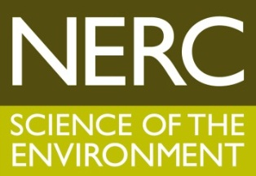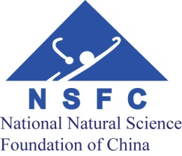



Increasing Resilience to Natural Hazards in Earthquake Prone Regions of China: Expression of Interest form

Essential information for applicants
- One Expression of Interest is required for each proposed project.
- Completed Expressions of Interest must be submitted via email to both NERC at IRNHNWT@nerc.ac.ukby 16:00 UK time (BST) and NSFC at xoc@nsfc.gov.cn by 16:00 China time on 9th June 2015. Applications received after this time will not be accepted.
- Applications must be submitted following the word limits as instructed and following all instructions in the Announcement of Opportunity. Applications which fail to comply with any of the guidance supplied will be rejected.
- Applicants must fill in all sections of this form.
- Applications must be submitted in English and Chinese.
- Applications must be submitted as a Word document.

COMPLIANCE WITH THE DATA PROTECTION ACT 1998
In accordance with the Data Protection Act 1998, the personal data provided on this form will be processed by NERC, and may be held on computerised database and/or manual files.

GENERAL INFORMATION
UK Investigators (please delete or add lines as appropriate)
Role: (PI, CoI, etc.) | Name: | Organisation: | Division/Department: | Hours per week on project:

Chinese Investigators (please delete or add lines as appropriate)(注：该表格请用中英两种语言填写)
Role: (PI, CoI, etc.) | Name: | Organisation: | Division/Department: | Hours per week on project:

Project title [limit 150 characters]:
（请用中英文两种语言填写）

Themes addressed (please indicate which themes you plan to address in your proposal; tick at least two boxes)

The understanding of the fundamental mechanisms and processes (physical and social) through the hazard chain that can lead to disaster.

Hazard monitoring, forecasting and warning.

Risk mitigation, management and preparedness.

Context-specific hazard risk communication.

Resilience, recovery and reconstruction.

Proposed start date (expected January2016):
Duration of grant (months) (should finish by January 2019):

Project Partners (if any)（请用中英文两种语言填写）
Name: | Organisation: | Input into project (funds, advice, facilities, etc.) and whether proposed or secured:

Composition, expertise and experience of project team, including any previous collaborations[limit 500 words]

Outline of research proposed, including how it addresses the programme requirements, both scientific and technical and non scientific requirements[limit 1000 words]

Identify potential linkages with other themes and routes to integrate[limit 500 words]

Expected outcomes of the research and how they relate to ODA compliance; impacts and their pathways[limit 500 words]

Nominated reviewers for Full Proposal (max 4)
Name of reviewer | Organisation | Email address

RESOURCES
Estimated resources requested
UK resources £ (at 80% FEC)
China resources YUAN

Proposed use of NERC facilities (UK applicants only)

